
Draft AGENDA –eTw seminar
“Rural Teachers from Mediterranean Countries together at European School Education Platform”

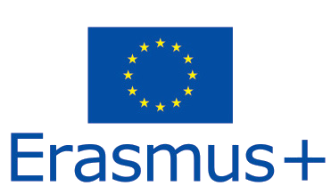
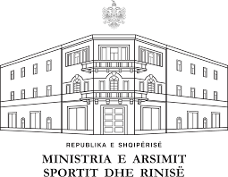

26-28 September
Durres 2022

Day 1, Monday
15.30 - 16.00 | Registration of participants/Welcome cocktails
16.00 - 16.30 | Welcome speech and introduction
16.30 - 17.30 | EU login and registration process to ESEP- Coffee break served
17.30 – 18.30 | Networking activity
20:00 | Dinner
Day 2, Tuesday
09.00 - 10.30 | Our schools beautiful, sustainable and inclusive/Bauhaus concepts-Different ideas
10.30 - 11.00 | Coffee break
11.00 - 12.30 | Networking on European School Education Platform-ESEP. How to collaborate with other teachers. How to use Partner finding
12.30 - 13.30 | Lunch
13.30 - 15.00 | Building up ideas for different Mediterranean projects Planning projects among different participants(Team work)
15.00 - 15.30 | Coffee break
15.30 - 17.00 | Projects on ESEP. How to register them and how to use functionalities of Twinspace on ESEP
18.00 | Cultural programme and Dinner
Day 3, Wednesday
09.30 - 10.30 | Presentation of their projects by groups
10.30 - 11.00 | Coffee break
11.00 - 12.30 | Using different ICT tools in teaching and learning process
12.30 - 13.00 | Closing and certificates
13.00 | Lunch

Working language: English
Size of group: up to 80 participants
Target group: Teachers from rural areas of Mediterranean countries

This project has been funded with support from the European Commission. This communication reflects the views only of the author, and the Commission cannot be held responsible for any use which may be made of the information contained.



