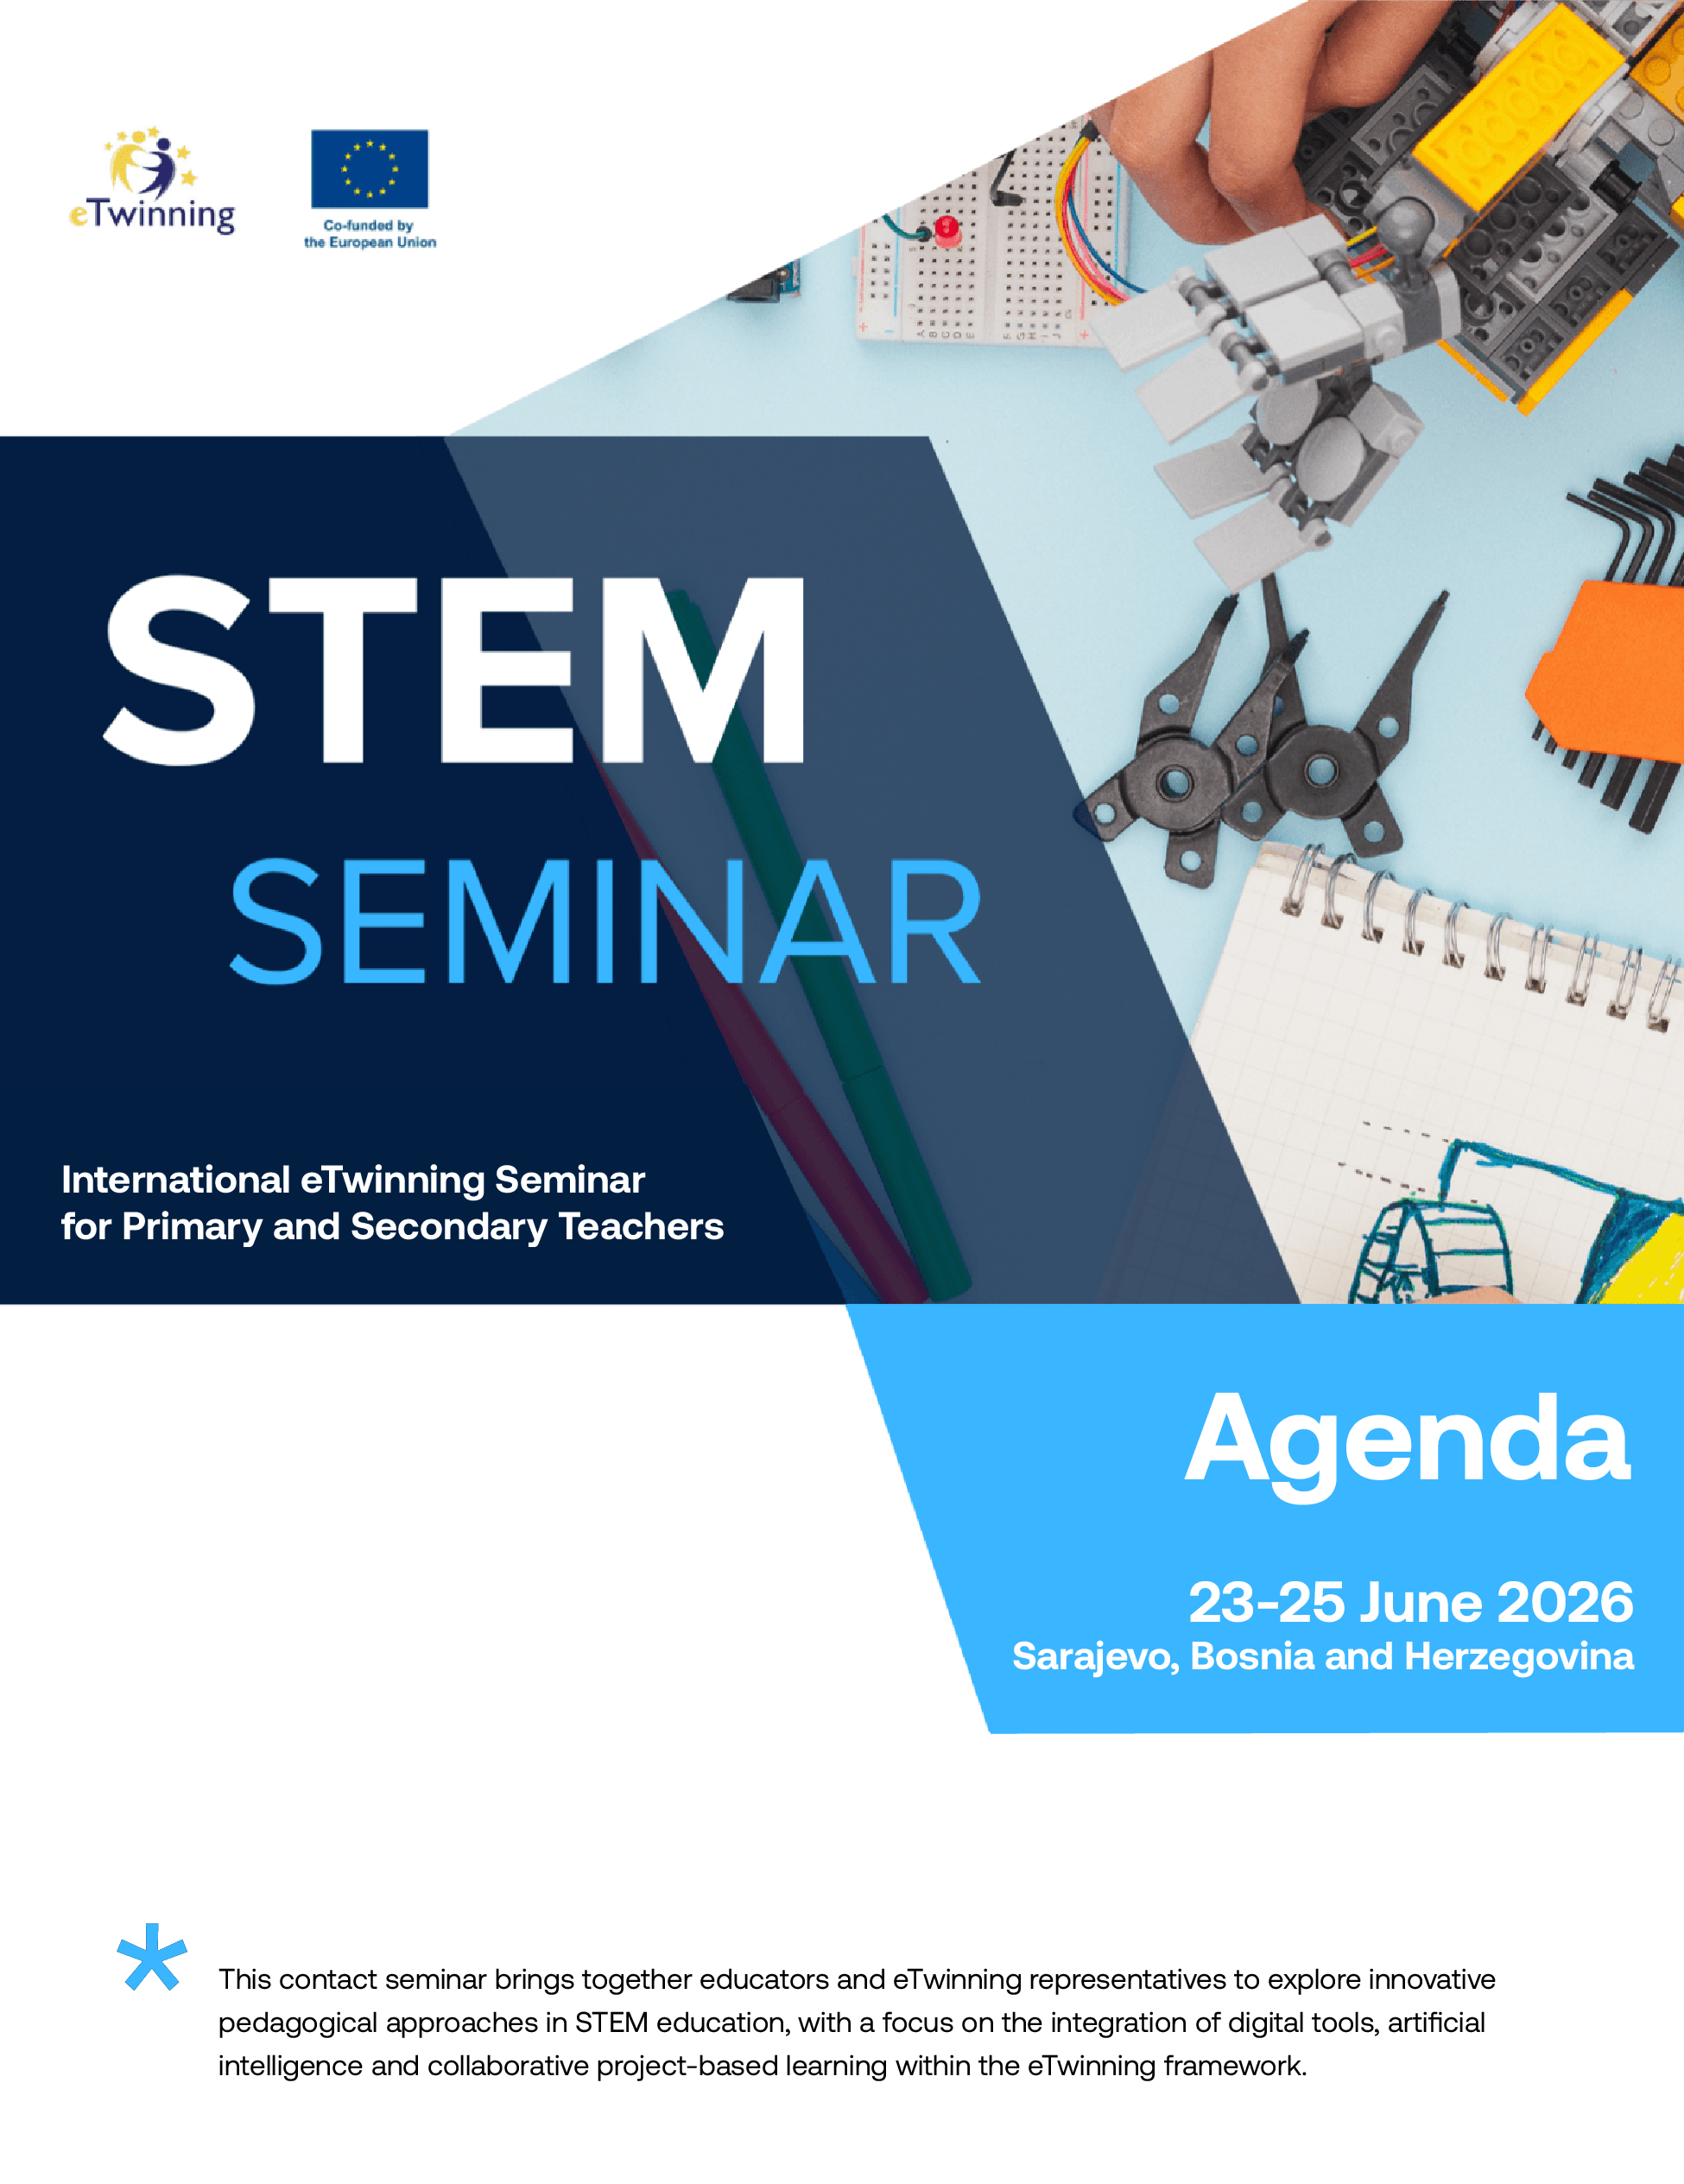

Tuesday, 23 June 2026
Venue: Hotel Hollywood, Sarajevo, Bosnia and Herzegovina
17:15 - 17:45 Local time | Registration and welcome coffee
17:45 - 18:15 | Official Opening and Welcome Remarks  Representative of Ministry of Civil Affairs BiH, TBD  Ms. Maja Stojkić, Director of Agency for Pre-Primary, Primary and Secondary Education (APOSO)  Ms. Aida Terzić, Deputy director, eTwinning national coordinator, APOSO  Mr. Nikos Tzimopoulos - Coordination of the STEM GR Action- GR NSO
18:15 - 19:15 | Keynote Session  Keynote Speech 1  eTwinning GR Action: “Pedagogical development of ICT and Web 2.0 tools, educational robotics and mobile devices for collaborative activities to eTwinning projects and integration into curriculum”.  Mr. Andreas Galanos GR NSO  Keynote Speech 2  Mr. Borislav Vukojević – Topic TBD
19:15 - 19:45 | Networking Activity  NSO BiH
20:00 | Welcome Reception/Buffet Dinner

Wednesday, 24 June 2026
Venue: Hotel Hollywood, Sarajevo, Bosnia and Herzegovina
10:00 - 11:30 | Workshop Session I*
11:30 - 12:00 | Coffee break
12:00 - 13:30 | Workshop Session II*
13:30 - 14:30 | Lunch
16:30 | Guided tour and cultural activity
20:30 | Dinner in the City

* Workshop Session I

Group 1
Exploitation of Micro:bit in eTwinning projects
Ms. Maria Iosifidou, GR NSO

Group 2
Utilization of artificial intelligence tools in STEM eTwinning projects

Mr. Nektarios Farassopoulos GR NSO

* Workshop Session II

Group 1
Utilization of artificial intelligence tools in STEM eTwinning projects

Mr. Nektarios Farassopoulos GR NSO

Group 2
Exploitation of Micro:bit in eTwinning projects
Ms. Maria Iosifidou, GR NSO
For the optimal running of the workshops, you need to bring your devices (laptops, iPad, tablet).

Thursday, 25 June 2026
Venue: Hotel Hollywood, Sarajevo, Bosnia and Herzegovina
09:30 - 10:30 | Twin space and Collaboration in eTwinning projects  Mr. Andreas Galanos GR NSO  Ms. Azra Šoše, NSO BiH, eTwinning ambassador
10:30 - 11:00 | How to plan and register an eTwinning project  Mr. Nektarios Farassopoulos GR NSO  Ms. Edisa Zilić, NSO BiH, eTwinning ambassador
11:00 - 11:30 | Coffee break
11:30 - 12:30 | Presentation of Registered projects on platform  Mr. Andreas Galanos GR NSO  Mr. Nektarios Farassopoulos GR NSO  Ms. Azra Šoše, Ms. Edisa Zilić, NSO BiH, eTwinning ambassadors
12:30 - 13:00 | Closing of the Seminar
13:00 | Lunch

